**Connecting the Xbox controller to Raspberry Pi to control IRacer Car**

The Xboxdrv operates by receiving raw data from the controller and passes the interpreted data to the kernel. Also the Xboxdrv includes a list of configuration tweaks such as; button mapping and mouse and keyboard emulation. The following syntax is used interface pygame with the Xboxdrv and installing the Xbox driver on the terminal. Also this syntax shows one led light on the Xbox controller.



**Figure 1**

To set up the Xbox controller with a python script, install the controller in silent mode. The silent mode allows the controller to connect with the Raspberry pi operating system (**figure 1**).



**Figure 2**

If an error occurs with the silent mode, use the following syntax will detach the kernel driver that is related with a particular device and loading the Xbox controller if the silent mode is not successful. Plus the following the syntax checks to see if the controller inputs are recognised (**figure 2**).



**Figure 3**

Once the Xbox controller is connected to the raspberry pi operating system, open python IDLE and enter the following code to import the libraries necessary to interface with the Xbox 360 controller (**figure 3**).

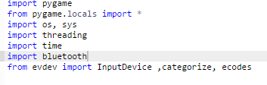

**Figure 4**

* Pygame : - input library used for joy sticks
* OS : - module which provides operating system dependent functionality
* Sys ; - provides information about constants , methods and functions
* Time; handles dates and time of the system
* Bluetooth ; socket used for Bluetooth communication
* edev; read and write input events
* Threading; module which allows the multiple operations to work concurrently on the same space

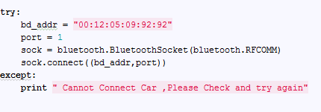

**Figure 5**

To control the Car using the Xbox controller, the connection to the Bluetooth device needs to be verified. The Code above checks if a Bluetooth connection is made from raspberry pi to the IRacer Car. Plus binding the port and mac address of the car and making a socket connection. If not the terminal will print an error indicating that there is no connection established (**figure 5**).

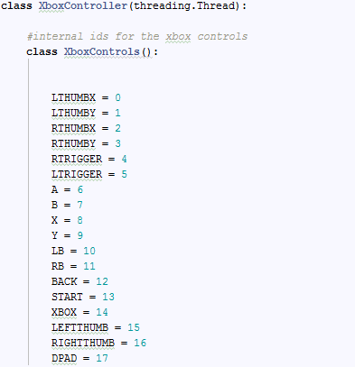

**Figure 6**

The Xbox Controller main class is handled by the thread and the variables for each button on the Xbox controller are declared with numerical values used by ids Xbox controls (figure 6).

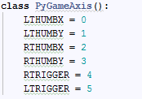

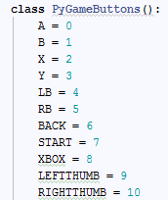

**Figure 7**

Seeing as variables for the Xbox Controller are declared with an ids control, the Pygameaxis and the pygameButtons class are responsible for defining constants for trigger buttons and normal button variable (**figure 7**).

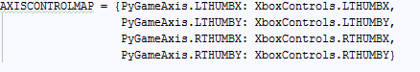

**Figure 8**

The Axiscontrolmap variable is assigned as array of ids controls for pygame constants which are mapped with the analogs ids for the Xbox Controller (**figure 8**).



**Figure 9**

The Trigger variable is assigned as array of ids controls for pygame constants which are mapped with ids for right and left triggers for the Xbox Controller (**figure 9**).

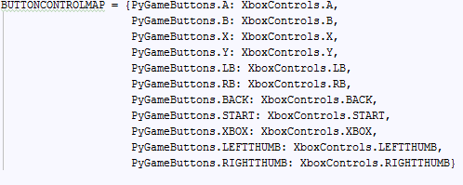

**Figure 10**

Buttoncontrolmap is assigned with an array of normal buttons that are mapped with the normal buttons such as; A, B, X, Y(**figure 10**).

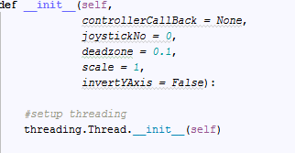

**Figure 11**

The following syntax illustrates the instance of the Xbox controller class in the main method. The self object variable is a global variable used to call functions for the Xbox controller. This functions specifies the number of pygame controllers in which a user wants to use, it is usually set as Zero and the dead zone adjusts the sensitivity of the analogue sticks. The scale is used to return values between -1 and 1, 0 is constantly in the middle.

InvertYAxis, inverts the assigned values for moving the analogues up and down since -1 is up and 1 is down.The InvertYaxis inverts the values for analogue sticks (**figure 10**).

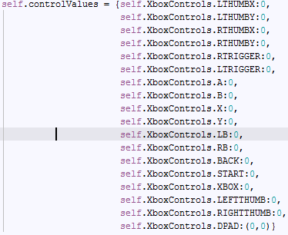

**Figure 11**

The control value function is defined as an array of Xbox controls which are assigned for one Controller (**figure 11**).



**Figure 12**

As soon as the Properties are defined with a control setup pygame with the joystick number (**figure 12**).

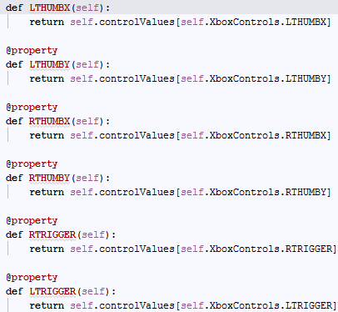

**Figure 13**

All buttons which are mapped by pygame are set with a different property and each property is given with a function. For def DPAD (self) controls the properties the directional button on the controllers (**Figure 13**).

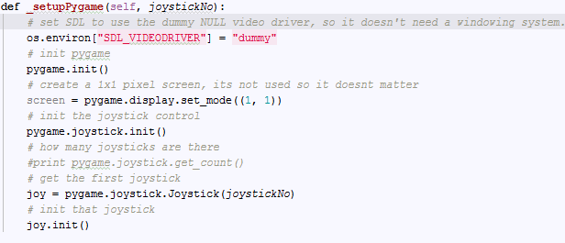

**Figure 14**

This function sets up pygame with the Xbox controls and sets up a dummy video driver to make sure SDL does not need windowing. SDL is constructed to write portable multi-media applications that can run on Raspberry pi (**Figure 14**).

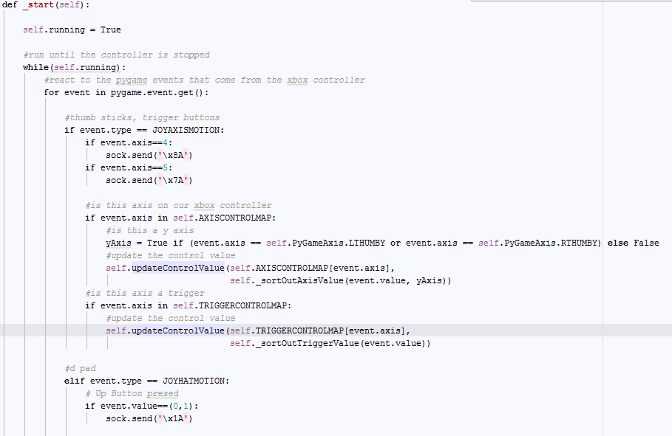

**Figure 15**

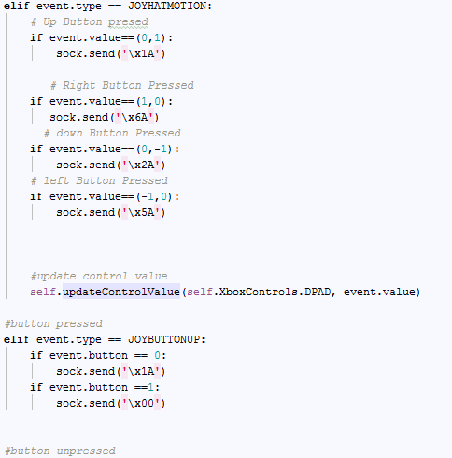

**Figure 17**

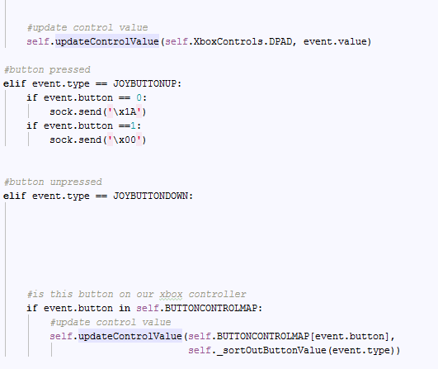

**Figure 18**

The start function will launch the Xbox controller until the controller is stopped. A for loop will iterate the events of the control and check if trigger buttons are pressed or not pressed **(figure 17).**

. Each time a button is pressed or not pressed a control byte is sent to Bluetooth Car. Also the start function makes sure all buttons for the trigger and main buttons are set to its correct function and updates the control value (**figure 18**).

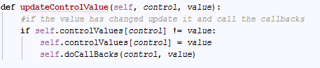

**Figure 19**

The following method updates controls id for the Xbox controller the values are changed and updates the specific control in the dictionary (**Figure 19**).

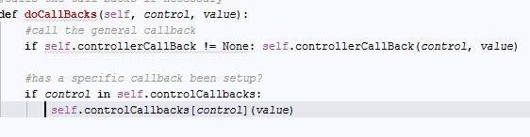

**Figure 20**

Checks to see if a call-backd are made and to all control functions of the Xbox controller

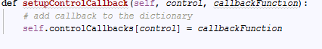

**Figure 21**

As soon as the control ids are updated the call and makes call back to a control on the Xbox controller (**figure 21**).

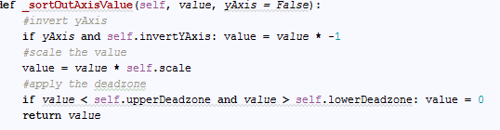

**Figure 22**

This function scales inverts the axis of analogues and apply the deadzone while scaling the control value (**Figure 22**).

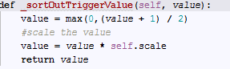

**Figure 23**

SotoutTriggerValue function is responsible for turning the trigger values into something readable and scales it. If the button is down its 1 and if the button is up its

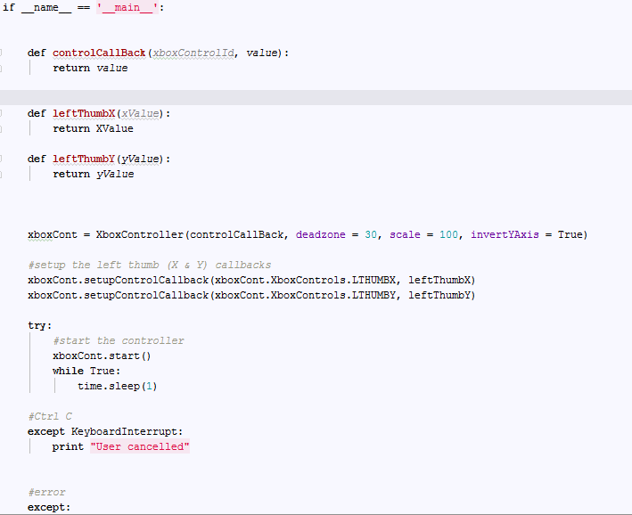

**Figure 24**

Lastly the program tests if control values are returns and makes specific call backs to vertical and horizontal movements of the analogue sticks. Plus setting the controller and scaling the invert access is pygame direction button for up is negative. Set up control backs for the vertical and horizontal movements of the controller.

Also the function starts the Xbox controller and makes validation of user input (figure 24)